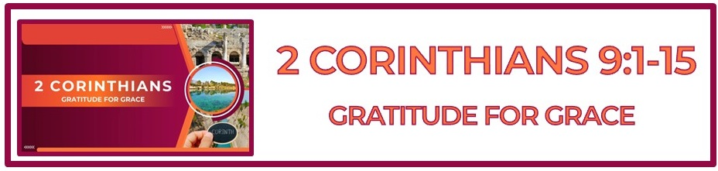

**The Bottom Line:**

**Generosity is to bring gratitude to God**

**for ____________ we have received from God**

**The righteous acts of faithful saints serve to: (VS 1-2, Hebrews 10:24-25)**

1. Generously meet needs from a heart of ___________ and ________________ to God

2. Stir up the love and good works of ____________ ________________.

Good works which stir up the saints are not a matter of ______________ but of _______________. **(VS 1-2)**

In God’s design, the body of Christ takes care of the church by means of _______________ and _______________ giving. **(VS 5-15)**

The believer’s offering must always flow from ____________-filled generosity and never from guilt-filled grudge. **(VS 5, 2 Corinthians 8:1-2)**

**The fruit of generosity: (VS 6-15)**

1. The generous are ______________ **(VS 6-10)**

2. The receiver is ______________ **(VS 11-12)**

3. The intercessor is _______________ **(VS 14)**

4. The supplier (God) is ______________ **(VS 13, 15)**

The reliability of seed time and harvest is not only a _______________ principle but a ________________. **(VS 6-7, Genesis 8:22)**

Knowing the size of harvest comes from the seed, by ____________, we sow, let us sow generously and with a cheerful heart. **(VS 6-7)**

**Cheerful (VS 7)**

*Hilaros (Strong’s G2431)*

*I. cheerful,* ***_____________****, prompt to do anything*

If your ______________ is ____________ leave your offering in the bank. **(VS 6-7, Proverbs 11:24-26)**

Giving is not a question of quantity but of confidence. Do I __________ ________? **(VS 8, Philippians 4:19)**

**The part of provision that comes from God (VS 9-10)**

1. ___________

2. ____________

3. _____________

4. _____________________ of all of the above

**The part of provision that comes from you (VS 9-10)**

**1. ______________**

Faithful givers are _______________ to _____________ others. **(VS 11-13)**

The __________ of giving is met need, the ____________ of giving is to bring praise and glory to God.

**(VS 12-13)**

When each member of the church faithfully gives according to ability, the needs of the church as a whole will _____________ be met. **(VS 11-13)**

Generosity is to bring ________________ to God for grace we have received from God. **(VS 15)**

**Life Group Application Questions**

**1. Are there areas in your life where you’ve made promises to give or serve but haven’t yet**

**acted? What steps can you take to follow through? (VS 1-5)**

**____________________________________________________________________________________****____________________________________________________________________________________________________________________________________________________________________________________________________________________________________________________________**

**2. How does the principle of sowing and reaping encourage or challenge you in your giving, whether it’s time, money, or resources? (VS 6)**

**____________________________________________________________________________________________________________________________________________________________________________________________________________________________________________________________________________________________________________________**

**3. Do you trust God to supply what you need when you step out in faith to help others? How has God proven His faithfulness in your life in this way? (VS 8-10)**

**____________________________________________________________________________________________________________________________________________________________________________________________________________________________________________________________________________________________________________________**

**4. What question was not asked that should have been?**

**________________________________________________________________________________________________________________________________________________________________________________________________________________________________________________________________________________________________________________________________________________**

**Notes:**

**____________________________________________________________________________________****________________________________________________________________________________________________________________________________________________________________________________________________________________________________________________________________________________________________________________________________________________****________________________________________________________________________________________________________________________________________________________________________**