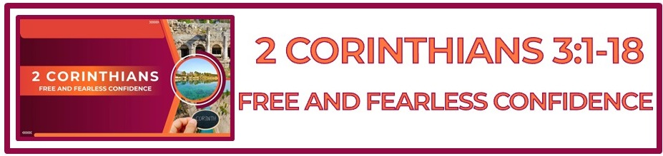

**The Bottom Line:**

**Increasing ____________ in the believer, is born of**

**fearless confidence in the God of the gospel.**

Changed lives are the ____________ of effective ministry.

True life transformation can never come by human means, but only through the __________________ of the gospel which comes from God. **(1 Corinthians 2:1-5)**

_______________ _________________ in the life of the believer is natural if it is founded in the power of the cross, the truth of the Word and the work of The Holy Spirit.

The Holy Spirit _____________ works by means of God’s written word!

The Holy Spirit will never speak or lead in any way that runs counter to the written Word of God! ____________!

While many Christians live life pursuing a “greater glory,” they fail to see and remember the _____________ itself is the greater glory the Old Testament saints could only wonder about. **(1 Peter 1:10-12)**

**Boldness**

*Parrēsia (Strong’s G3954)*

***___________*** *and* ***_______________*** *confidence, cheerful courage, boldness, assurance*

God uses those who trust the gospel to do what the gospel ___________ _________ ___________ _________.

**The end**

*Telos (Strong’s G5056)*

II. the end

1. the last in any succession or series

2. eternal

3. that by which a thing is **_______________**, its close, issue

4. the end to which all things relate, the aim, **______________**

True freedom is possible because Christ has redeemed us from the slavery of sin and enabled us to be ______________, not as slaves, but as children of God. **(Galatians 4:5-7)**

In The Old Testament, Moses removed his veil in the presence of God. In the New Testament the ___________ _____________ removes the veil of blindness allowing us to see the truth of Christ and experience freedom as sons and daughters of God.

Contrary to Moses’ fading glory, the believer’s transformation is an ever-increasing manifestation of God’s glory from ________________ to _____________________, to ____________________.

**Life Group Application Questions**

**1. How is fearless confidence in God’s purpose different than prideful arrogance in self? (VS 1-6, 1 Corinthians 2:1-5)**

**________________________________________________________________________________________________________________________________________________________________________________________________________________________________________________________________________________________________________________________________________________________________________________________**

**2.** **How does the work of the Holy Spirit relate to the written Word of God? (VS 4-6)**

**________________________________________________________________________________________________________________________________________________________________________________________________________________________________________________________________________________________________________________________________________________**

**3. In what way are believers transformed “from glory to glory?” (VS 18)**

**________________________________________________________________________________________________________________________________________________________________________________________________________________________________________________________________________________________________________________________________________________**

**4. What question was not discussed here that should have been?**

**________________________________________________________________________________________________________________________________________________________________________________________________________________________________________________________________________________________________________________________________________________**

**Notes:**

**____________________________________________________________________________________****________________________________________________________________________________________________________________________________________________________________________________________________________________________________________________________________________________________________________________________________________________****________________________________________________________________________________________________________________________________________________________________________________________________________________________________________________________________________________________________________________________________________________________________________________________________________________________________________________________________________________________________________________________________________________________________________________________________________________________________________________________________________________________________**